Project B: Reflective Raytracing Marvels

NetID: MKO6761

Madhav Khanna

# **USER GUIDE:**

## Basic Controls:

**Use you mouse** to interact with the scene

* Press the left button and drag the mouse to look around in the scene.

**Use W, A, S, D** to move in the scene.

**Press T** to trace the Image

**Press the Scene button** to change the scene.

## Advanced Controls:

The program has DAT-GUI based user interactions and therefore most of the features, are interactable from the drop-down menu at the top right of the webpage.

There are three elements the user can interact with through the DAT.GUI menu:

* **Ray Tracer Settings:** These settings include the settings that impact how the image is rendered as and has the following sub settings:
  + **Anti-Aliasing:** The user can select which anti-aliasing he would like the image to be processed with
  + **Jittered:** If the check box is ticked a ‘Jittered’ Anti-aliasing will be performed on the image.
  + **Recursions:** This dictates how many reflection recursions deep the Ray-Tracer should go.
* **World Light Settings:** These settings are for the world light in the scene which is always switched ‘On’.It has the following settings:
  + **Position:** The user can adjust the position of the light.
  + **Colour:** The user can adjust the different colours for the light.
* **Portable Light Settings:** This is the settings for the second portable light in the scene as a default this light is always switched off, but you can enable this from the DAT.GUI Menu.

**\*NOTE: AFTER SELECTING ANY OF THE SETTINGS PLEASE PRESS RELOAD OF THE PARTICULAR SETTING TO ENSURE THE CHANGES ARE SAVED AFTER WHICH PRESS ‘T’ TO TRACE THE IMAGE AGAIN.**

# **RESULTS:**

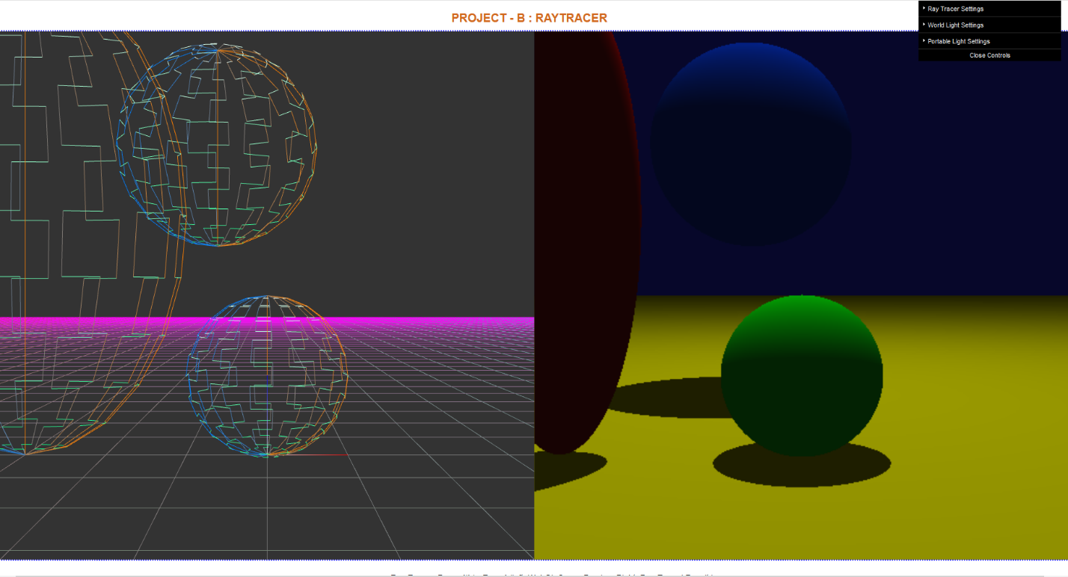

***Figure 1:*** *The start-up screen of the program*

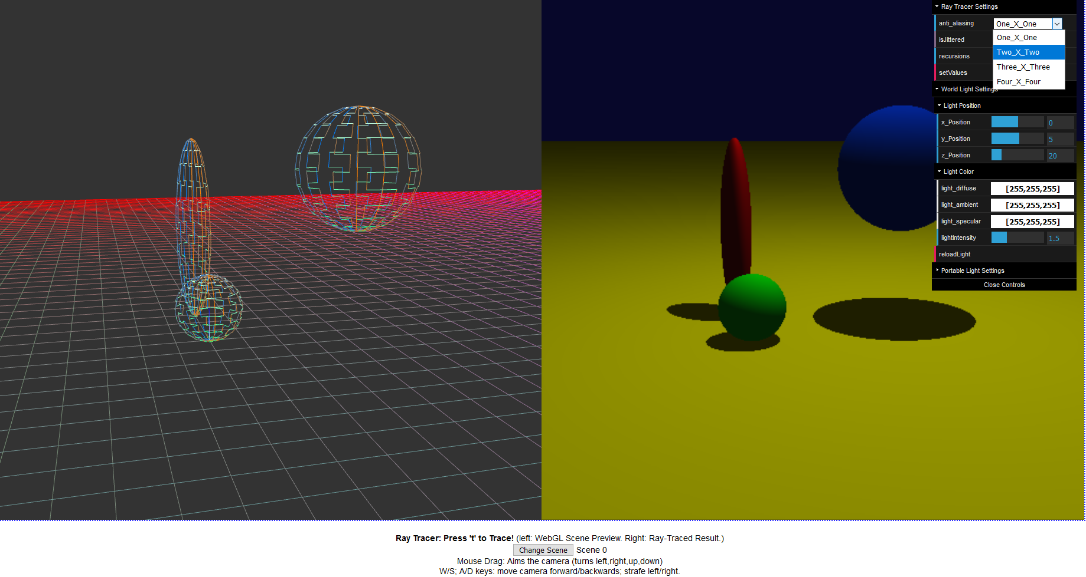

***Figure 2:*** *Changing Anti-aliasing from DAT.GUI Menu*

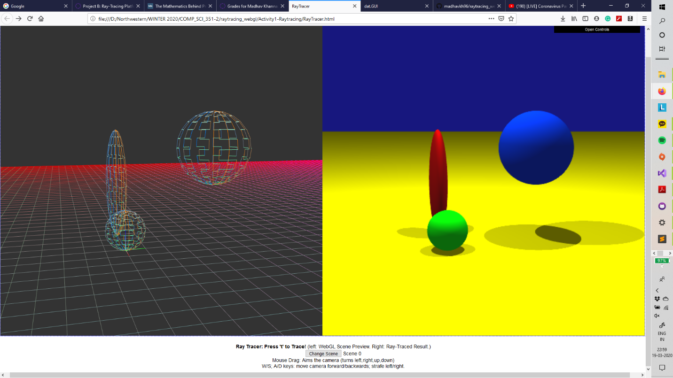

***Figure 3:*** *Multiple Lights Toggles showcasing different shadows and Union of two shadows.*

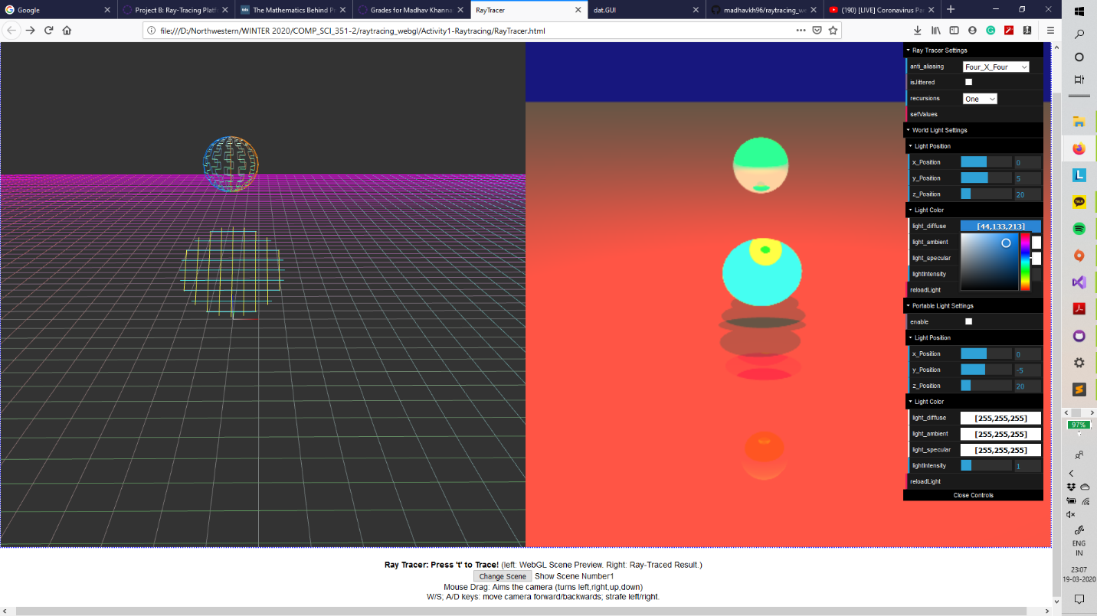***.***

***Figure 4:*** *Changing the Colour of World Light to get Different Results*

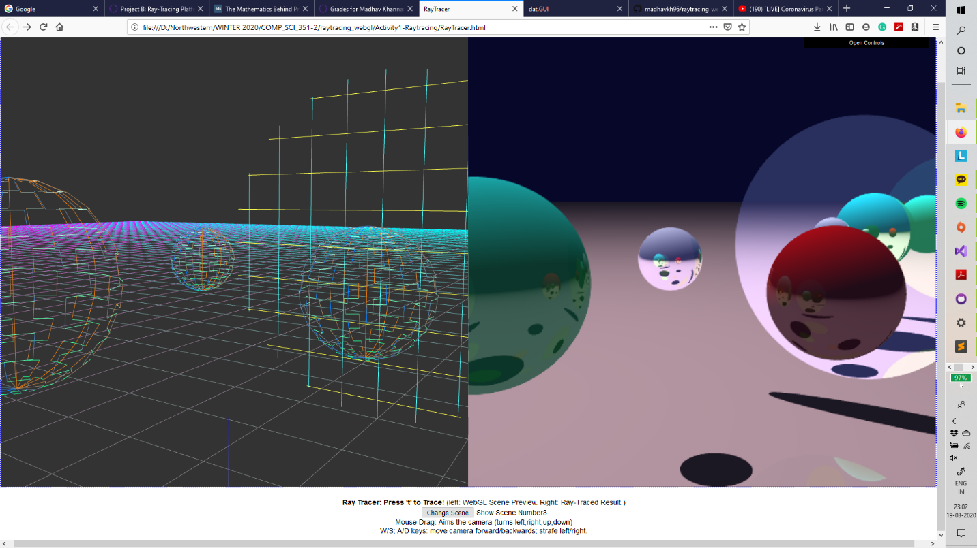

***Figure 5:*** *Multiple reflections with and Anti-Aliasing of 4x4*